Foundations in Excel and Art of Presentation

# What is MS-Excel?

It is a spreadsheet program developed by Microsoft. It comes with Office Suite with several other Microsoft applications, such as Word, Powerpoint, Access, Outlook, OneNote, etc. Excel organizes data into columns and rows and allows you to perform mathematical functions, create optically logical charts, and more. It is compatible with Windows, Mac OS X, Android, and iOS. While you may believe that only specific people use Excel to process complex data, anyone can learn how to use the program's sophisticated features. Excel makes it simple to work with various types of data, whether you're tracking a budget, organizing a training log, or preparing an invoice.

This Microsoft Excel tutorial for beginners includes in-depth instructions on how to utilize Excel formulas, tables, and charts to manage small to large-scale business activities.

# Why do we use Excel?

Excel is typically used for:

## Data Entry and Storage:

If there is a need for data entry and data storage software, Excel is best for organizing and storing the data in tabular format. However, the size of the data to be stored in Excel is limited to 1,048,576 rows and 16,384 columns. Once the data is stored in an excel file, we can use it for various purposes.

## Performing Calculations:

Excel has a large number of built-in functions and formulas that can be used to execute specific tasks on data. Excel has about 450 features that are organized into different categories. Mathematical, statistical, logical, string, and DateTime functions are some of the most popular functions. These functions can be applied to any data row and column. Excel also has VBA and Macros features, which allow us to design our custom features to perform certain data operations.

## Data Analysis and Interpretation:

Apart from being a data storage tool, excel has many features for data analysis that can directly assist any organization in making decisions and gaining meaningful insights from data. We may utilize built-in methods to calculate data and transform

it into a pivot table that focuses on the most important parts of enormous datasets. Using functions like sorting, filtering, and conditional formatting, a table can be managed more systematically to carry out the essential data fields. Additionally, these insights assist us in maintaining a complete data analysis report.

## Reporting and Visualization:

Without displaying the data in the form of charts, graphs, or other visualizations, the analysis is incomplete. These can make the analysis report more attractive and useful. Charts can express the desired outcome better than the massive table. MS- Excel comes with several built-in charts that we can use to analyze the data. We can make a line chart, a bar chart, a pie chart, and so on. To build charts in Excel, we only need to select a template and choose the input data. It also includes tools for creating custom charts. You can also use Excel to create a dashboard with all of these charts.

## Accounting and Budgeting:

Account manager's responsibilities include keeping track of customer's or employee’s records, and they use Excel for this. With basic editing features, it makes it simple to keep track of all the records in an orderly and up-to-date manner. Excel includes many accounting and budgeting templates that make keeping records easier. Make computations, some of them include basic to advanced formulas. This allows managers to use the information from Excel and share it with others when necessary for the organization.

# Use Cases of Excel in Companies

## Finance and Accounting:

Microsoft Office Excel is designed to support accounting functions such as budgeting, preparing financial statements, and creating balance sheets. It integrates with external data to allow you to import and export banking information and financial data to and from other accounting software platforms. Performing line calculations is a basic accounting task, and Excel spreadsheets are designed to contain data in a tabular format that supports both in-line and summation calculations.

Additionally, you can create charts and graphs from the spreadsheet data, creating a media-rich user experience and different views of the same data. Budget plans, forecasts, expense tracking, financial reports, loan calculators, and more, Excel is pretty much designed to meet these different accounting needs. Excel even has numerous different spreadsheet templates to make all of those processes that much easier.

## Human Resource Planning:

HRM's key goal is to maximize productivity while maintaining within budget and benefiting the firm as a whole. Employee compensation, staffing, and work plans are some of the subcategories of HRM. HR specialists will utilize Excel to analyze a massive spreadsheet of employee data to determine where the expenditures are coming from and how best to plan and control them in the future. Users may utilize Excel to spot trends, summarise spending and hours by pay period, month, or year, and better understand how their personnel is distributed by function or pay level.

## Marketing and Project Management:

While marketing and product managers rely on their finance departments to do the hard work when it comes to financial research, using spreadsheets to track customer and sales targets can help you manage your salesforce and plan future marketing strategies based on past performance. With an easy drag-and-drop, users may quickly and simply summarise customer and sales data by category using a pivot table. Excel can help you map out a project schedule and phases by creating a visual timeline chart. You can make a Gantt chart, which is a common project management tool that plots tasks based on how long they'll take, when they'll begin, and when they'll end. Creating a budget is very easy if all you want is to track a shortlist of expenses against a list of incomes. But if you want to go beyond that and create more detailed budgets, Excel can do that as well.

# How to open MS-Excel?

* To start, press the Start button.
* Look for the Microsoft Excel application.
* It will look like this if it is already installed on your PC.
* To open Excel, double-tap on this icon.

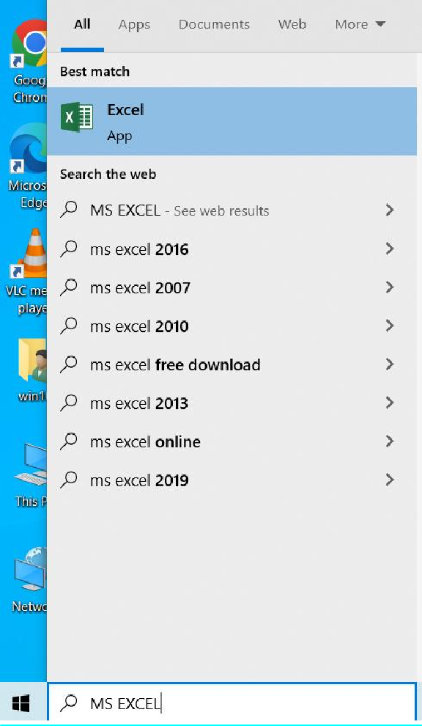

When you first launch Excel, you'll see something like this. You can create a new workbook, select a template, and see your recently changed workbooks from here.

- To create a new workbook, click on the blank Workbook.

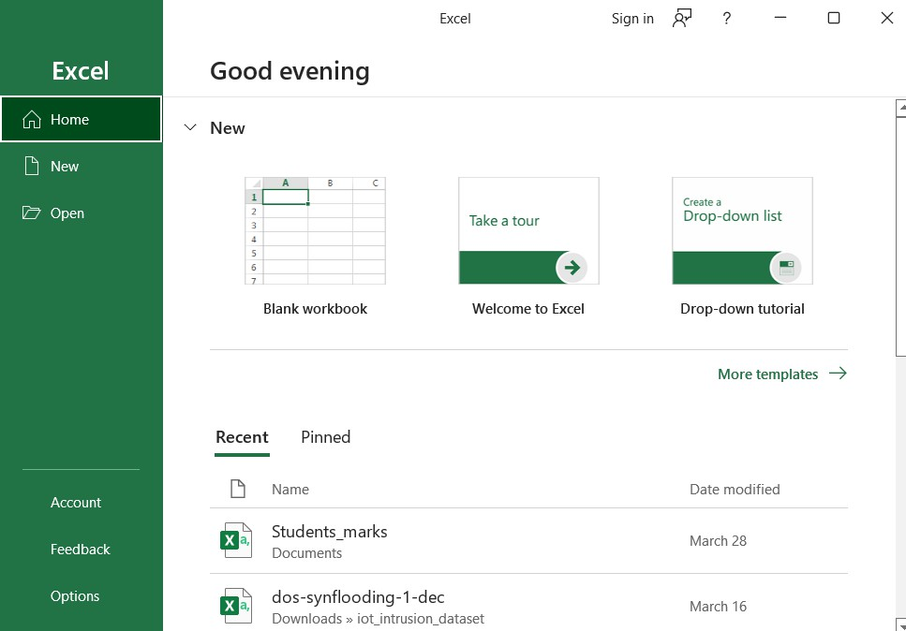

**New Workbook**

* A blank Excel worksheet will open and displayed it to you.

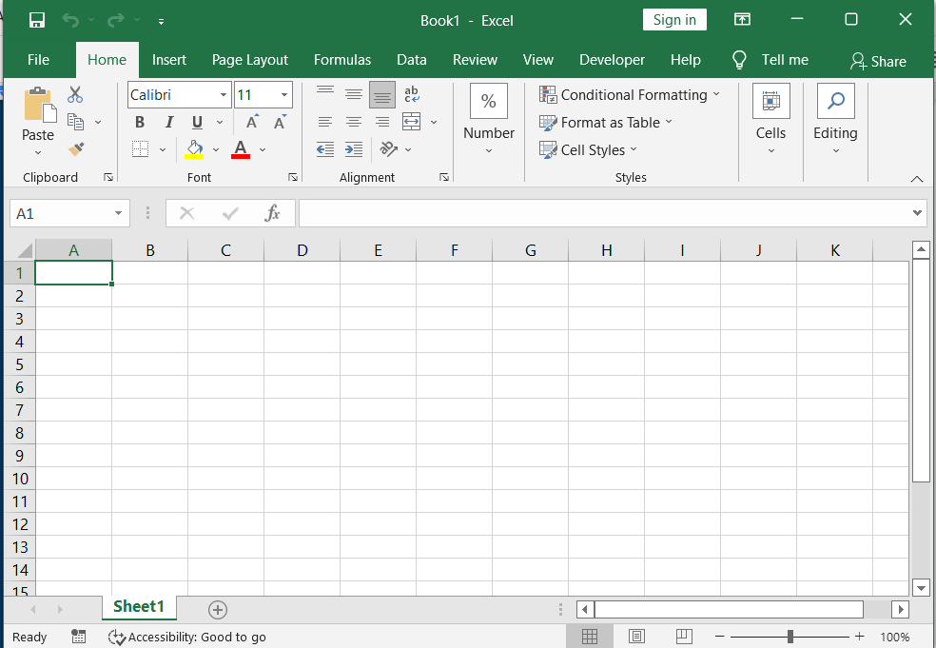

* If you want to work with an existing worksheet that you have worked on recently or is available on your PC, you can either select it from the **Recent** list or use the **Open** option to browse to a specific location.

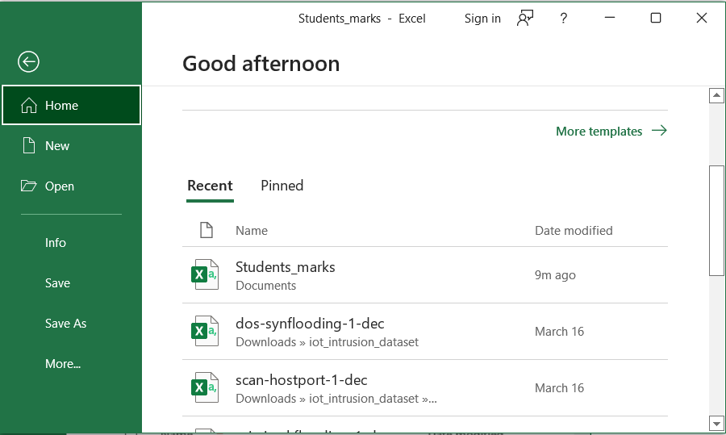

* When you click the Open option, it will prompt you to choose from a variety of locations to open the existing file, including Recent, This PC, and Browse.
* This time, we'll use Browse, which will take you right to the local computer. You can select the Excel file you want to open from this menu.
* Click the Open button after selecting a file from your PC.

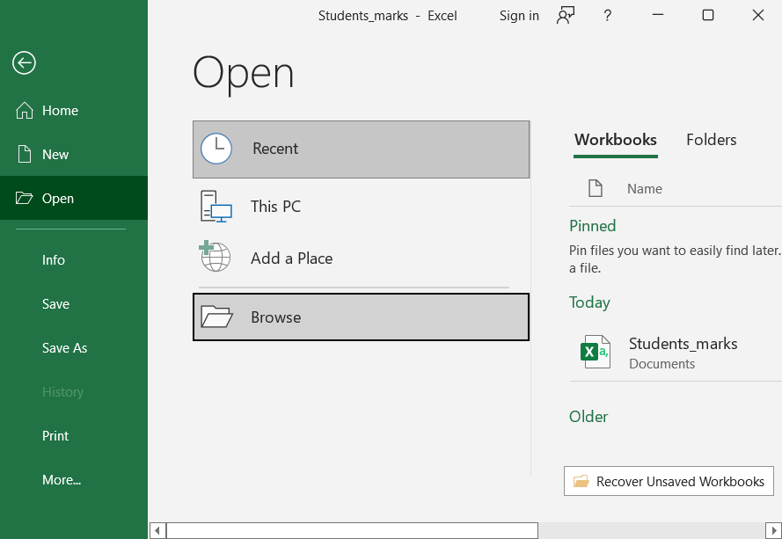

# Explore the user interface of Excel

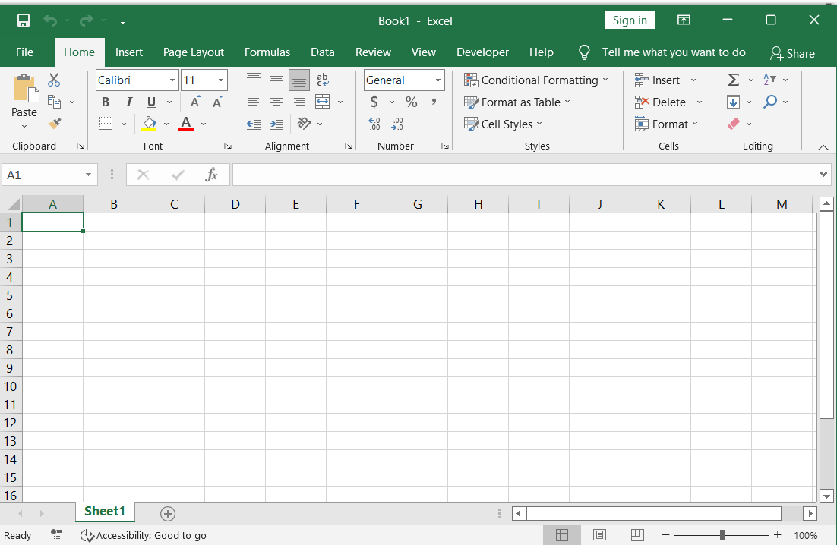

Horizontal Scroll Bar

Status

Zoom slider

Cell

Row

Column

Formula Bar

Quick Access Toolbar

Ribbon

Title Bar

## Title Bar

It can be found on top of the excel window or next to the quick access toolbar. It shows the name of the currently open document.

## Ribbon

Instead of typical menus, Excel offers a tabbed Ribbon system. The Ribbon has various tabs, each with a different set of commands. These tabs will help you accomplish the most frequent Excel activities. A command is an action that allows you to make something happen. The Ribbon is made up of the App launcher, Tabs, Groups, and Commands.

The buttons and icons of the Excel Ribbon are organized into separate tabs based on their functionalities. Home, Insert, Page Layout, Formulas, Data, Review, and View are the seven tabs.

Each tab contains its own set of related commands. By clicking the arrow in the right bottom corner of any group, you can see a list of additional commands for that group.

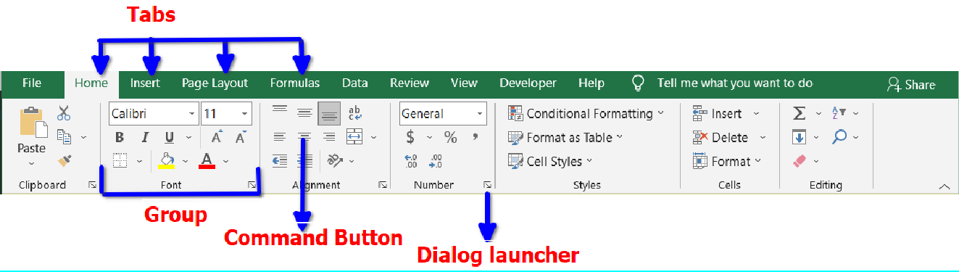

The Ribbon in Excel is made up of four basic components, such as:

**Tabs:** It contains several commands that are logically grouped into categories.

**Group:** A group of connected commands that are usually executed as part of a bigger task.

**Dialog launcher:** A little arrow in the lower-right corner of a group pulls up further related instructions via the dialogue launcher. Dialog launchers appear in groups that contain more commands than available space.

**Command button:** It is the button that you press to conduct a certain action.

The following tabs are found on the standard Excel ribbon, from left to right:

**File:** It opens the backstage view, which contains all of the necessary file-related commands and Excel settings. This tab replaced the Office button in Excel 2007 and the File menu in previous versions of Excel 2010.

**Home:** This section comprises the most commonly used commands, such as copying and pasting, sorting and filtering, formatting, and so forth.

**Insert:** This command is used to add photos, charts, PivotTables, hyperlinks, special symbols, equations, headers, and footers to a worksheet.

**Draw:** It is dependent on the sort of gadget you are using. You can use a digital pen, mouse, or finger to sketch. The Developer tab is accessible in Excel 2013 and beyond, however, it isn't shown by default.

**Page Layout:** It gives options for controlling the appearance of worksheets on screen and in print. Theme settings, gridlines, page margins, object alignment, and print area are all controlled by these tools.

**Formulas:** It includes tools for entering functions, naming variables, and manipulating computation settings.

**Data:** This section contains commands for manipulating worksheet data and connecting to external data.

**Review:** You can use it to double-check the spelling, keep track of changes, add comments and notes, and lock worksheets and workbooks.

**View:** Switching between worksheet views, freezing panes, viewing, and organizing numerous windows are all commands available in View.

**Help:** It appears only in Excel 2019 and Office 365. This tab opens the Help Task Pane, allowing you to contact Microsoft support, provide comments, suggest a feature, and view training videos quickly.

**Developer:** It gives you access to complex capabilities like VBA macros, ActiveX and Form controls, and XML instructions as a developer. By default, this tab is hidden, and you must first enable it.

Add-ins: Open an older workbook or load an add-in that customizes the toolbars or menu, and it appears.

## To change the ribbon display options

The Ribbon is designed to respond to your current task, but if it takes up too much screen space, you can choose to minimize it. To access the drop-down menu, click the Ribbon Display Options arrow in the upper-right corner of the Ribbon.

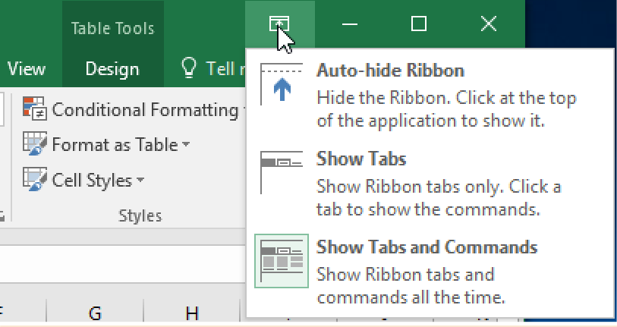

The Ribbon Display Options menu has three modes:

### Auto-hide Ribbon:

Auto-hide conceals the Ribbon and puts your worksheet in full-screen mode. Click the Expand Ribbon command at the top of the screen to see the Ribbon.

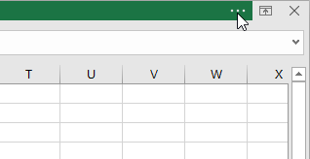

### Show Tabs:

When this option is selected, all command groups are hidden. When they are not in use, tabs remain visible. Simply click a tab to bring up the Ribbon.

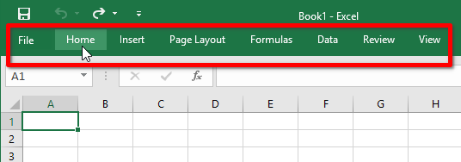

### Show Tabs and Commands:

This option maximizes the Ribbon by displaying tabs and commands. You'll be able to see all of the tabs and commands. When you launch Excel for the first time, this option is chosen by default.

## Customizing Ribbon

By building our tabs with the commands we desire, we may customize the Ribbon. A group contains all commands, and we can create as many groups as we wish to keep our tab structured. We can even add commands to any of the standard tabs if we build a new group in the tab first.

* Choose Customize the Ribbon from the drop-down menu after right-clicking the Ribbon.

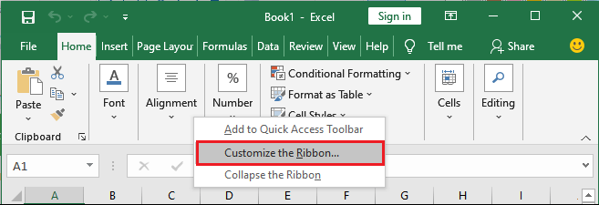

* A dialogue window called Excel Options will appear. Choose **New Tab** or

**New Group**, depending on what you want to add.

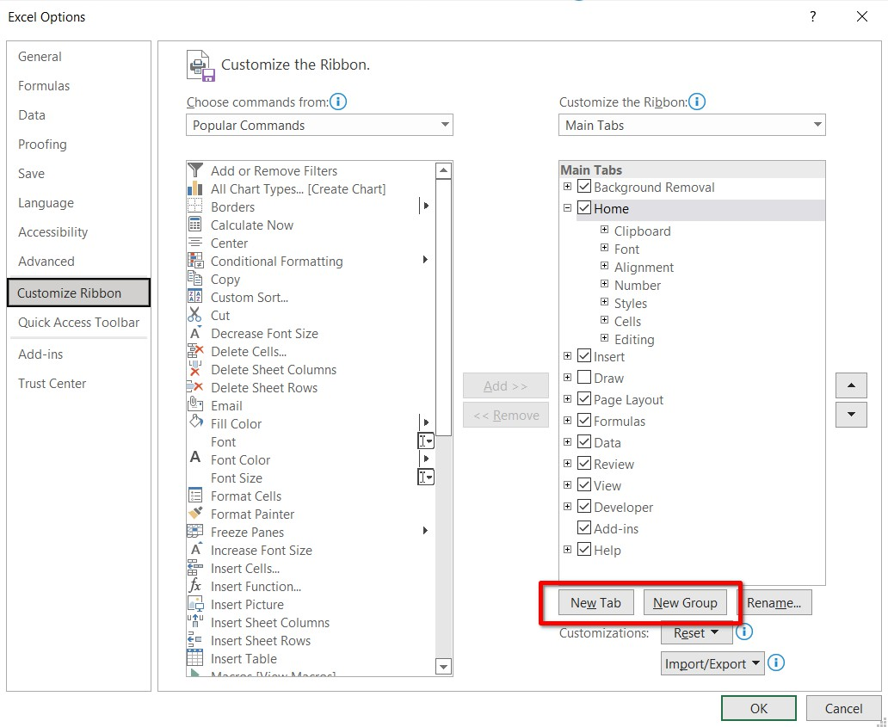

* Select a command from the left panel and add it to the new customized tab/group by clicking the **Add** button. You may also drag and drop instructions into a group.

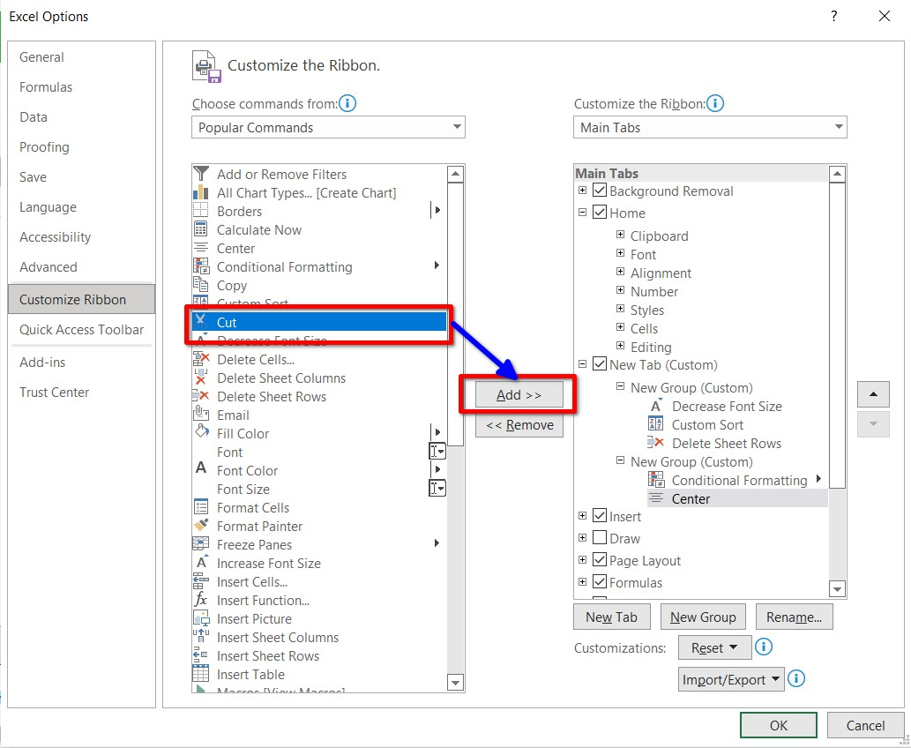

* Click OK when you're finished adding commands. In a new tab like this, the commands will be added to the Ribbon.

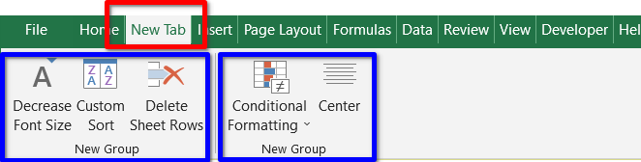

## Quick Access Toolbar

The objective of this toolbar, which is located directly above the File tab, is to provide a convenient resting place for Excel's most commonly used commands. This toolbar can be customized to suit your needs.

## Status Bar

This shows the current state of the worksheet's active cell. Any of the four states are possible for a cell.

* + - 1. **Ready** mode signifies that the worksheet is ready to receive user input.
      2. **Edit** mode indicates that the cell is in editing mode; if it is not active, double- clicking on a cell will do so.
      3. When a user types data into a cell, it enters **Enter** mode.
      4. **Point** mode triggers when a formula is being entered using a cell reference by mouse pointing or the arrow keys on the keyboard.

## Formula Bar

We can enter or change data, a formula, or a function that will be used in a specific cell in the formula bar. It allows you to write data manipulation functions and formulas. Cell A2 is selected in the image below, and 4500 is entered into the formula bar. Take note of how the data is represented in both the formula bar and cell A2.

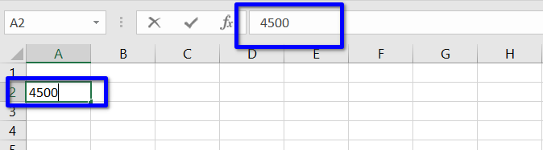

## Name Box

A selected cell's location or "name" is displayed in the Name box. Cell C4 is highlighted in the illustration below. It's worth noting that cell C4 is where column C and row 4 meet.

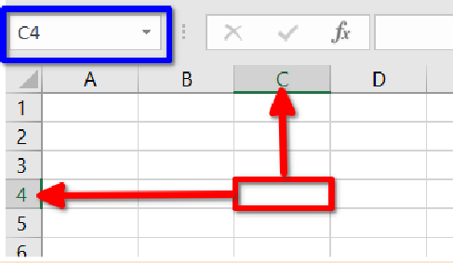

* 1. **Keyboard Shortcuts**

|  |  |
| --- | --- |
| **Keys** | **Function** |
| **Ctrl + N** | To create a new workbook. |
| **Ctrl + O** | To open a saved workbook. |
| **Ctrl + S** | To save a workbook. |
| **Ctrl + A** | To select all the contents in a workbook. |
| **Ctrl + B** | To turn highlighted cells bold. |
| **Ctrl + C** | To copy cells that are highlighted. |

|  |  |
| --- | --- |
| **Ctrl + D** | To fill the selected cell with the content of the cell right above. |
| **Ctrl + F** | To search for anything in a workbook. |
| **Ctrl + G** | To jump to a certain area with a single command. |
| **Ctrl + H** | To find and replace cell contents. |
| **Ctrl + I** | To italicize cell contents. |
| **Ctrl + K** | To insert a hyperlink in a cell. |
| **Ctrl + L** | To open the create table dialog box. |
| **Ctrl + P** | To print a workbook. |
| **Ctrl + R** | To fill the selected cell with the content of the cell on the left. |
| **Ctrl + U** | To underline highlighted cells. |
| **Ctrl + V** | To paste anything that was copied. |
| **Ctrl + W** | To close your current workbook. |
| **Ctrl + Z** | To undo the last action. |
| **Ctrl + 1** | To format the cell contents. |
| **Ctrl + 5** | To put a strikethrough in a cell. |
| **Ctrl + 8** | To show the outline symbols. |
| **Ctrl + 9** | To hide a row. |
| **Ctrl + 0** | To hide a column. |
| **Ctrl + Shift + :** | To enter the current time in a cell. |
| **Ctrl + ;** | To enter the current date in a cell. |
| **Ctrl + `** | To change the view from displaying cell values to formulas. |
| **Ctrl + ‘** | To copy the formula from the cell above. |
| **Ctrl + -** | To delete columns or rows. |
| **Ctrl + Shift + =** | To insert columns and rows. |

|  |  |
| --- | --- |
| **Ctrl + Shift + ~** | To switch between displaying Excel formulas or their values in the cell. |
| **Ctrl + Shift + @** | To apply time formatting. |
| **Ctrl + Shift + !** | To apply comma formatting. |
| **Ctrl + Shift + $** | To apply currency formatting. |
| **Ctrl + Shift + #** | To apply date formatting. |
| **Ctrl + Shift + %** | To apply percentage formatting. |
| **Ctrl + Shift + &** | To place borders around the selected cells. |
| **Ctrl + Shift +** _ | To remove a border. |
| **Ctrl + -** | To delete a selected row or column. |
| **Ctrl + Spacebar** | To select an entire column. |
| **Ctrl + Shift + Spacebar** | To select an entire workbook. |
| **Ctrl + Home** | To redirect to cell A1. |
| **Ctrl + Shift + Tab** | To switch to the previous workbook. |
| **Ctrl + Shift + F** | To open the fonts menu under format cells. |
| **Ctrl + Shift + O** | To select the cells containing comments. |
| **Ctrl + Drag** | To drag and copy a cell or to a duplicate worksheet. |
| **Ctrl + Shift + Drag** | To drag and insert the copy. |
| **Ctrl + Up arrow** | To go to the topmost cell in a current column. |
| **Ctrl + Down arrow** | To jump to the last cell in a current column. |
| **Ctrl + Right arrow** | To go to the last cell in a selected row. |
| **Ctrl + Left arrow** | To jump back to the first cell in a selected row. |
| **Ctrl + End** | To go to the last cell in a workbook. |
| **Alt + Page down** | To move the screen towards the right. |
| **Alt + Page Up** | To move the screen towards the left. |

|  |  |
| --- | --- |
| **Ctrl + F2** | To open the print preview window. |
| **Ctrl + F1** | To expand or collapse the ribbon. |
| **Alt** | To open the access keys. |
| **Tab** | Move to the next cell. |
| **Alt + F + T** | To open the options. |
| **Alt + Down arrow** | To activate filters for cells. |
| **F2** | To edit a cell. |
| **F3** | To paste a cell name if the cells have been named. |
| **Shift + F2** | To add or edit a cell comment. |
| **Alt + H + H** | To select a fill color. |
| **Alt + H + B** | To add a border. |
| **Ctrl + 9** | To hide the selected rows. |
| **Ctrl + 0** | To hide the selected columns. |
| **Esc** | To cancel an entry. |
| **Enter** | To complete the entry in a cell and move to the next one. |
| **Shift + Right arrow** | To extend the cell selection to the right. |
| **Shift + Left arrow** | To extend the cell selection to the left. |
| **Shift + Space** | To select the entire row. |
| **Page up/ down** | To move the screen up or down. |
| **Alt + H** | To go to the Home tab in Ribbon. |
| **Alt + N** | To go to the Insert tab in Ribbon. |
| **Alt + P** | To go to the Page Layout tab in Ribbon. |
| **Alt + M** | To go to the Formulas tab in Ribbon. |
| **Alt + A** | To go to the Data tab in Ribbon. |
| **Alt + R** | To go to the Review tab in Ribbon. |

|  |  |
| --- | --- |
| **Alt + W** | To go to the View tab in Ribbon. |
| **Alt + Y** | To open the Help tab in Ribbon. |
| **Alt + Q** | To quickly jump to search. |
| **Alt + Enter** | To start a new line in a current cell. |
| **Shift + F3** | To open the Insert function dialog box. |
| **F9** | To calculate workbooks. |
| **Shift + F9** | To calculate an active workbook. |
| **Ctrl + Alt + F9** | To force calculate all workbooks. |
| **Ctrl + F3** | To open the name manager. |
| **Ctrl + Shift + F3** | To create names from values in rows and columns. |
| **Ctrl + Alt + +** | To zoom in inside a workbook. |
| **Ctrl + Alt + -** | To zoom out inside a workbook. |
| **Alt + 1** | To turn on Autosave. |
| **Alt + 2** | To save a workbook. |
| **Alt + F + E** | To export your workbook. |
| **Alt + F + Z** | To share your workbook. |
| **Alt + F + C** | To close and save your workbook. |
| **Alt or F11** | To turn key tips on or off. |
| **Alt + Y + W** | To know what's new in Microsoft Excel. |
| **F1** | To open Microsoft Excel help. |
| **Ctrl + F4** | To close Microsoft Excel. |